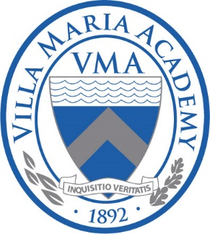
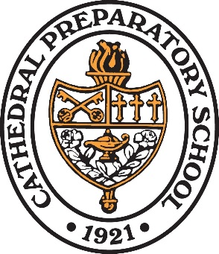

Catholic Elementary Scholarship Program
Cathedral Prep and Villa Maria Academy recognize the fact that tuition is the number one obstacle when it comes time to transition from a Catholic elementary school to Prep/Villa. As such, we are pleased to announce the creation of the Catholic Elementary Scholarship Program. Beginning with the class of 2019, any graduate of a Catholic elementary school in the Diocese of Erie will receive a $3,000 scholarship per year renewable for four years to attend Prep or Villa. The following is the qualification criteria for CESP:

- A student must be enrolled in a Catholic elementary school prior to the start of their 8th grade year.
- A student must graduate in good standing from a Catholic elementary school.
- A student must be accepted to Cathedral Prep or Villa Maria Academy.
- A qualifying family must apply for tuition assistance from Prep/Villa to receive the scholarship.
It’s that simple. Attend one of our Catholic elementary schools and save $12,000 or more on a Prep/Villa education!

Question: Is there still a possibility of additional tuition assistance above and beyond CESP if there is a demonstrated need?
Answer: Yes! Additional tuition assistance is available if needed through our traditional sources such as Endowment, Tax Credit Program, and Adopt-A-Student.

Question: The CESP scholarship is renewable for all four years?
Answer: Yes! So long as the student remains in good academic and behavioral standing.
Question: If a student doesn’t begin their schooling at a Catholic elementary school can they still qualify?
Answer: Yes! Although we would prefer a child enrolls at one of our Catholic elementary schools in Kindergarten, any student accepted at a Catholic elementary school prior to the start of their 8th grade year qualifies for CESP.
Question: Does my child still qualify if he/she is not Catholic but attends a Catholic elementary school?
Answer: Yes!
Question: Do all families qualify for CESP regardless of their income?
Answer: Yes! We do require that all families who wish to pursue CESP submit the required documents for tuition assistance.
Question: If a student transfers into Prep or Villa and demonstrates need will they qualify for tuition assistance?
Answer: Yes! However, they will not qualify for CESP.
Question: Is tuition assistance still available for students who attend public middle schools and wish to attend Prep/Villa?
Answer: Yes! So long as there is demonstrated need.

For more information about CESP, please contact Tim Dougherty, Director of Enrollment Management (Timothy.Dougherty@prep-villa.com/814-453-7737 x2242).

